**SETTING UP APPLICATION ENVIRONMENT**

**Docker CLI Installation**

**Step 1 :** Download Docker from docker.com and install it by running the Docker Desktop Installer.exe file.

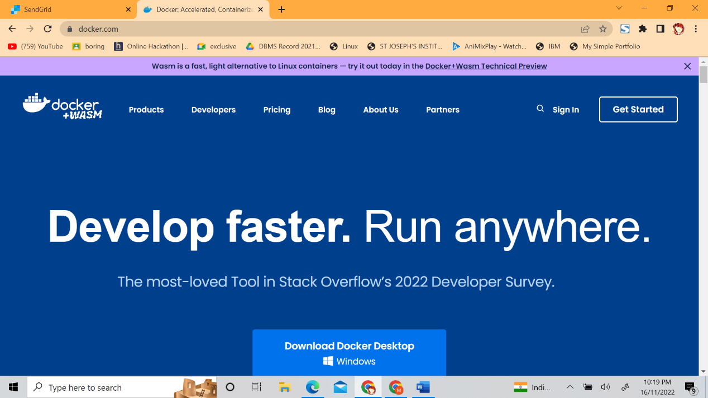

**Step 2.** Goto hub.docker.com register and create an account and login with the same .

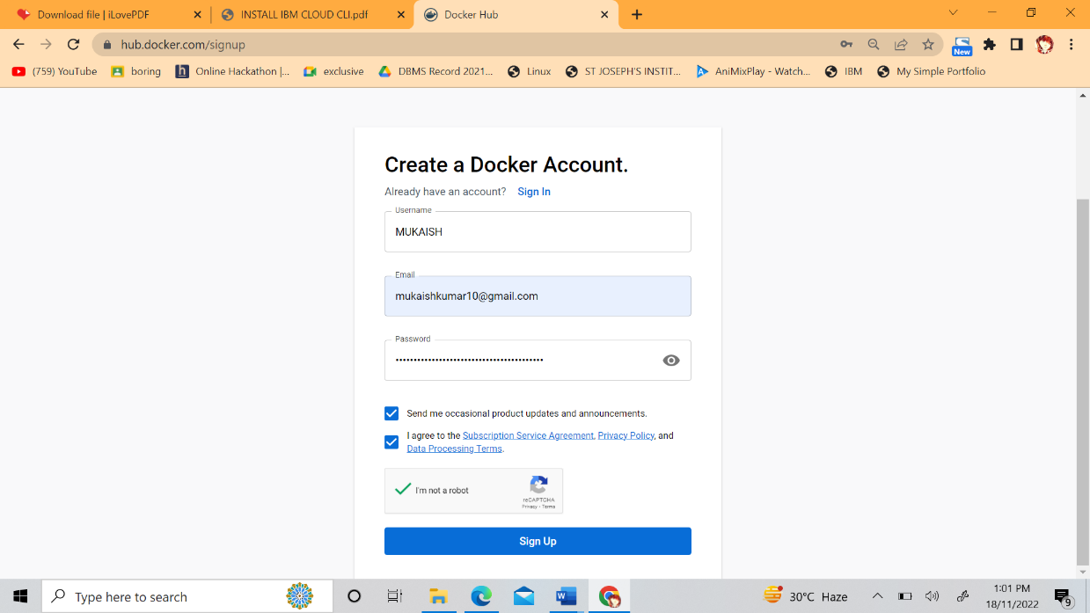

**Step 3.** Open Docker Desktop and start creating containers and images

